MODULE 3 AND 4

Q1. Simulate a small network with switches and multiple devices. Use ping to generate traffic and observe the MAC address table of the switch. Capture packets using Wireshark to analyze Ethernet frames and MAC addressing.
- Open Cisco Packet Tracer.
- Drag and drop the following devices:
1 Switch (e.g., Cisco 2960)
3 PCs
- Use Copper Straight-through cables to connect:
PC1 → FastEthernet 0/1 (Switch) PC2 → FastEthernet 0/2 (Switch) PC3 → FastEthernet 0/3 (Switch)
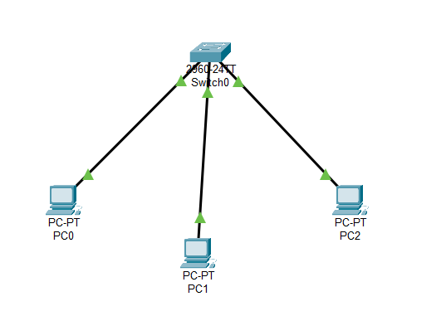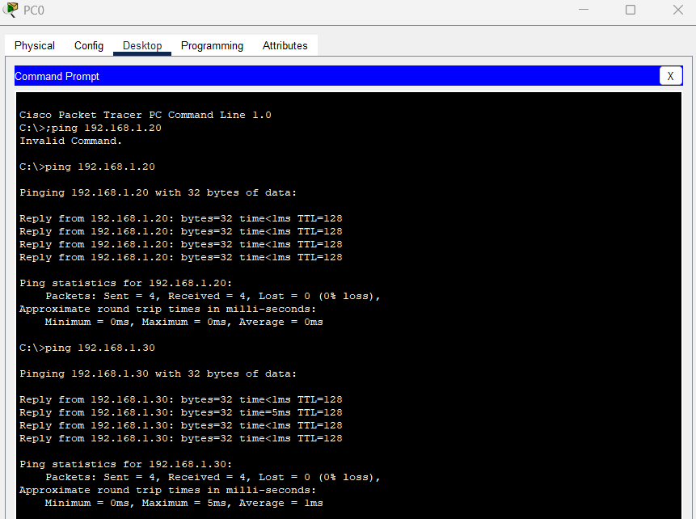
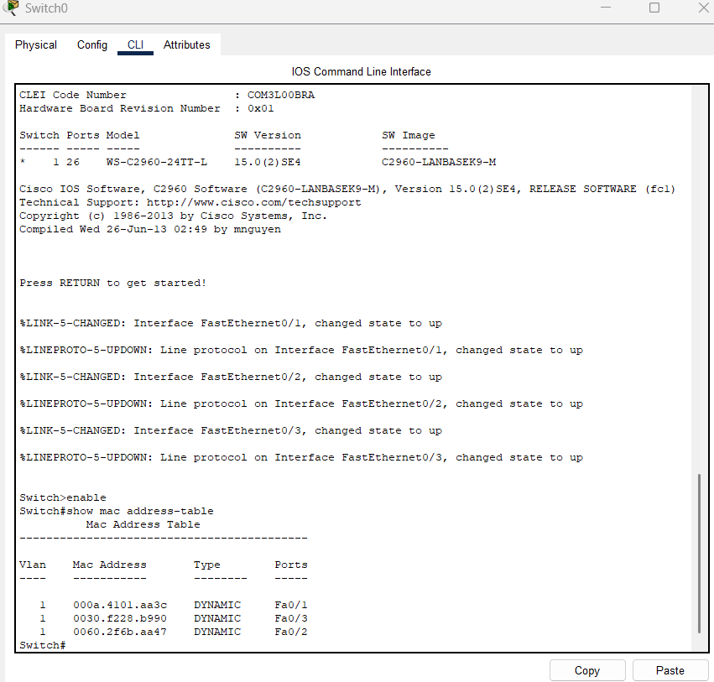
Q2. Capture and analyze Ethernet frames using Wireshark. Inspect the structure of the frame, including destination and source MAC addresses, Ethertype, payload, and FCS.
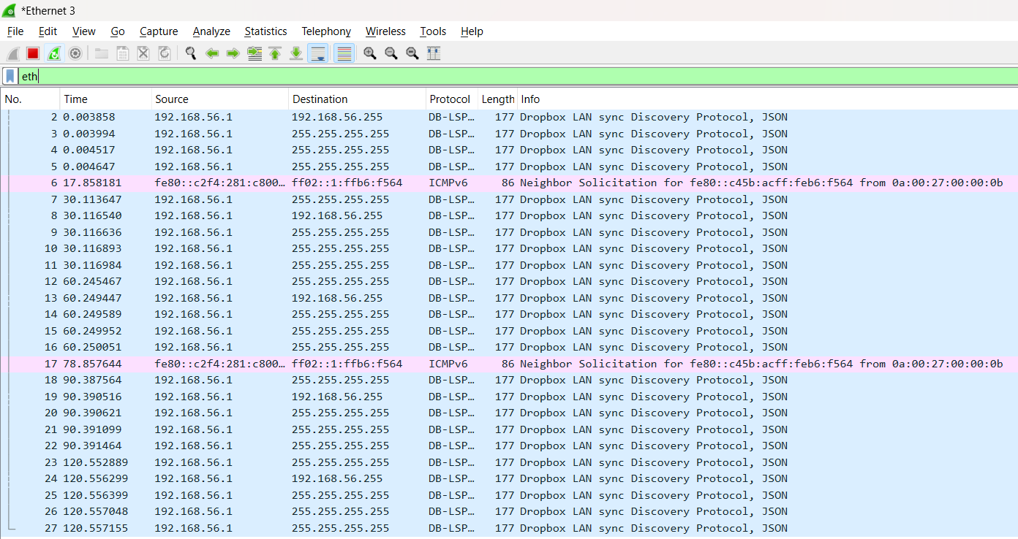
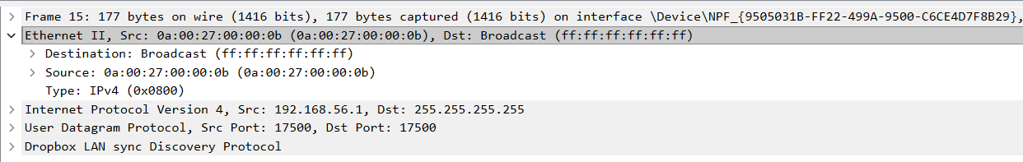
Q3. Configure static IP addresses, modify MAC addresses, and verify network connectivity using ping and ifconfig commands.
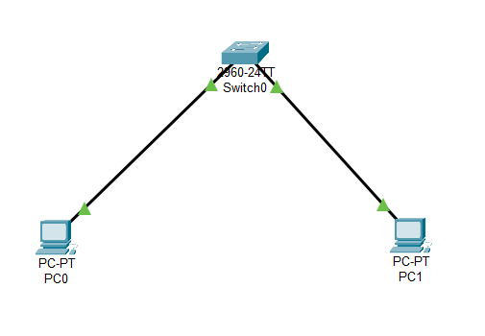
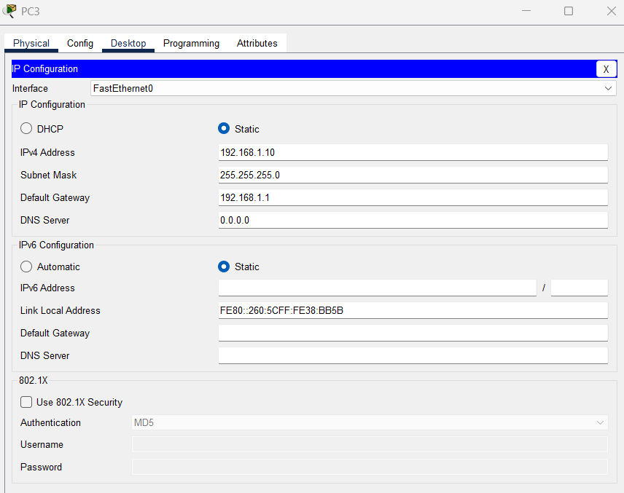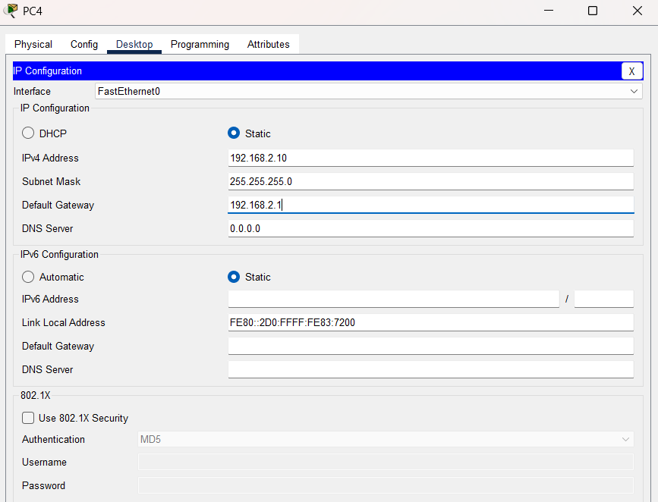
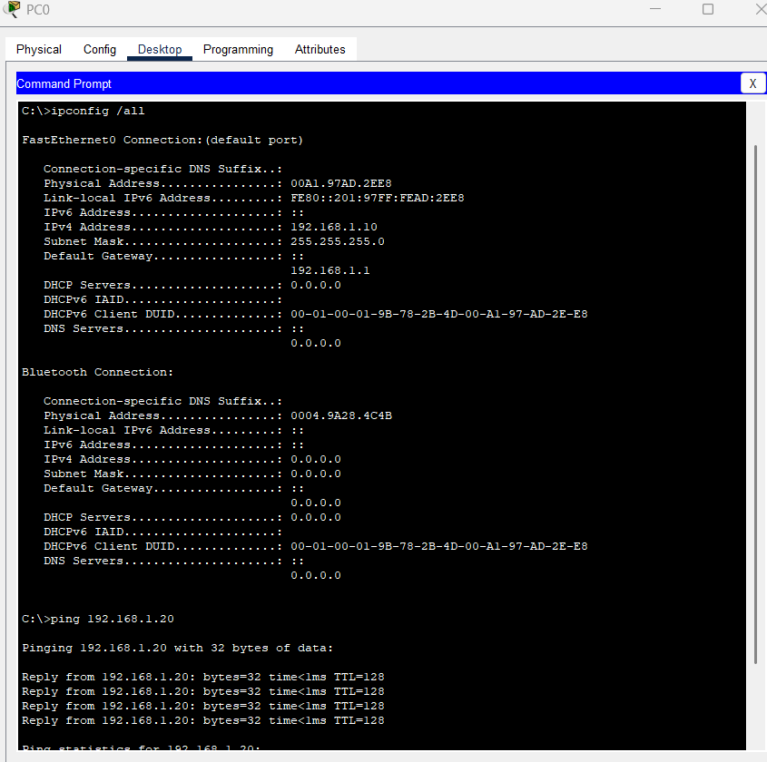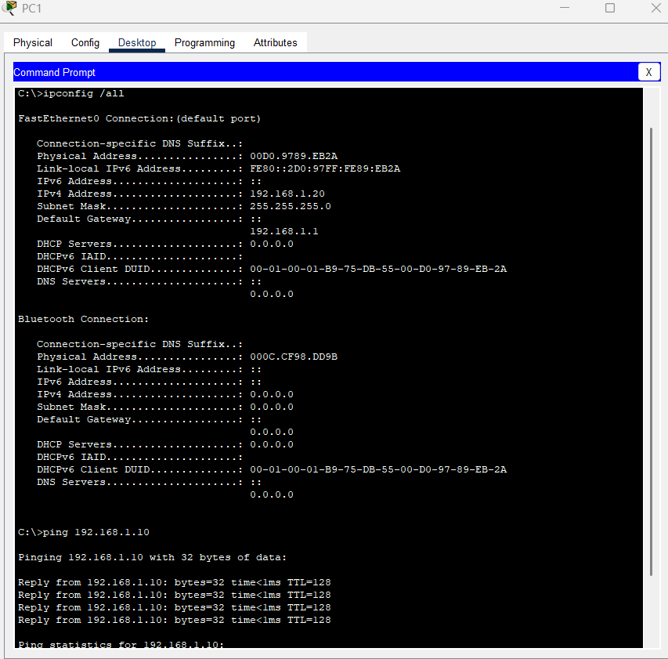
Q4. Troubleshoot Ethernet Communication with ping and traceroute -> Using cisco packet tracer:
Checked IP configuration with ipconfig.
Tested connectivity using ping.
Traced packet routes with tracert.

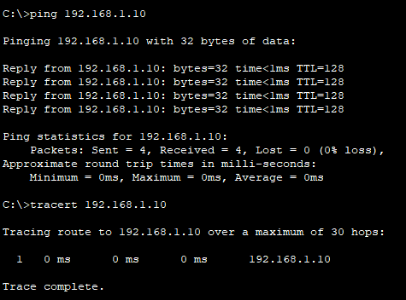

Q5. Create a simple LAN setup with two Linux machines connected via a switch. Ping from one machine to the other. If it fails, use ifconfig to ensure the IP addresses are configured correctly. Use traceroute to identify where the packets are being dropped if the ping fails.


Q6. Research the Linux kernel's handling of Ethernet devices and network interfaces. Write a short report on how the Linux kernel supports Ethernet communication (referencing kernel.org documentation).

The Linux kernel ensures smooth data transfer by working with network drivers, protocols, and system tools. Acting as a link between hardware and software, the kernel allows applications to send and receive data efficiently, ensuring a stable network connection.
It uses layered architecture :
1. Physical Layer – Responsible for transmitting raw data over physical cables and Network Interface Cards (NICs).
2. Data Link Layer – Manages data from the physical layer using device drivers and identifies the destination using MAC addresses.
3. Network Layer (IPv4/IPv6 Routing) – Routes data based on the MAC table and IP addresses. The ARP table assists in mapping IPs to MAC addresses.
4. Transport Layer – Uses TCP/UDP protocols for packet transport, handling flow control, congestion control, and error management. It also breaks requests into smaller packets for transmission.
5. Application Layer – Supports user programs that use system calls like send(), receive(), and socket() to transmit data over the network.
- When an application sends data, it goes through the socket API, where it is turned into packets following network rules.
- The Ethernet driver works with the Network Interface Card to send these packets over the network.
- When a packet arrives, the NIC detects it and passes it to the Ethernet driver, which sends it to the kernel.
- The kernel processes the packet, extracts the needed data, and delivers it to the right application using the socket API.
- This process ensures smooth and reliable network communication.

Q7. Describe how you would configure a basic LAN interface using the ip command in Linux (kernel.org).
1. Check for interfaces:
We need to check for all the available interfaces, using the command:
ip link show
2. Check whether the interface is up or down:
We can check whether the required interface like enpos3,eth0 etc. are up or down. If it is down we have to make that active, by giving the command
sudo ip link set enp0s3 up
3. Assign IP statically:
Next, I configure the network interface with a specific IP address. In this case, I assign 192.168.1.20 with a subnet mask of 255.255.255.0 using the following command:
ip addr add 192.168.1.20/24 dev enp0s3
4. Default gateway:
We can set the default gateway (e.g., 192.168.1.1) by using the command,
sudo ip route add default via 192.168.1.1
5. Verification :
To check if the IP address and routes are set correctly, I used the following commands,
ip addr show enp0s3
ip route show
6. Connectivity:
The connectivity can be checked using the ping command, which is:
ping 192.168.1.1
This setup ensures the LAN interface is properly configured for communication within the network

Q8. Use Linux to view the MAC address table of a switch (if using a Linux-based network switch). Use the bridge or ip link commands to inspect the MAC table and demonstrate a basic switch's operation.
A MAC address table is used by network switches to store MAC addresses and their corresponding interfaces.
When a switch receives a frame, it checks the source MAC address and associates it with the incoming port.
The switch adds or updates this entry in the MAC address table.
● If the destination MAC address is in the table, the switch forwards the frame to the correct port.
● If the MAC address is unknown, the switch sends the frame to all ports except the incoming one.
MAC table entries expire after a certain period if no traffic is received from that MAC address. This prevents stale entries and allows the table to update dynamically.
